Electric Future

Car edition



Isabella Frid

EC Utbildning

R Programming for Data Analysis

202404

# 

# Abstract

This project delves into the transition towards electric vehicles and the decreasing production of diesel and gasoline cars, and its impact on the environment. By examining trends in vehicle registration data from Statistiska Centralbyrån and exploring economic incentives, this research illuminates the acceleration adoption of electric cars. Additionally, regression modeling applied to current Blocket advertisements allows for the prediction of electric car prices in the forthcoming years. Through this multifaceted approach, the research sheds light on the evolving automotive landscape and its implications for sustainability.

# Abbreviations

RMSE – Root Mean Square Error

SCB – Statistiska Centralbyrån

VIF – Variance Inflation Factors

Table of Contents

Abstract 2

Abbreviations 3

1 Introduction 1

1.1 Overview of Electric Vehicles 2

2 Theory 3

2.1 Increase of Electric Vehicles 3

2.2 Economic Incentives for Electric Vehicles 5

2.3 Regression modeling for Price Prediction 7

2.4 Environmental Impact of Electric Vehicles 8

3 Method 9

4 Results 10

5 Conclusions 11

6 Answers to Questions 12

7 Self-Evaluation 13

Data collection 14

Source list 15

# Introduction

The global automotive industry is undergoing a significant transformation driven by the increasing awareness of environmental issues and the imperative to reduce carbon emissions. This shift is propelled by technological advancements, changing consumer preferences, and governmental policies aimed at promoting sustainable transportation solutions. Electric cars have emerged as a key player in this transition, offering a promising alternative to traditional engine vehicles.

The relevance of this work lies in its exploration of the accelerating transition towards electric vehicles and the corresponding decline in the production of diesel and gasoline cars. Understanding these dynamics is crucial for stakeholders across industries, including policymakers, automotive manufactures, and consumers, as it impacts not only the automotive market but also environmental sustainability efforts.

The purpose of this report is to explore the impact of changing towards a more electrical future by answering these questions;

1. What are the trends in vehicle registration data, and how do they reflect the adoption rate of electric cars?
2. What are the economic incentives that are driving the transition to electrical vehicles?
3. How can regression modeling be utilized to predict electrical car prices in the forthcoming future?
4. How does addressing these objectives contributes to a deeper understanding of the evolving automotive landscape and its broader implications for sustainability and economic development?

## Overview of Electric Vehicles

The first known electric car was manufactured in England in 1842, and have since then had a few eras – mostly because of wars and the difficulty finding and then affording gasoline, but most lately when Tesla entered the market in 2006 presenting Roadster.

The selling points of an electric car are many, appealing to environmentally conscious consumers and those seeking financial benefits and enhanced driving experiences. Key advantages include the reduction of emissions, lower taxes, and the provision of a more comfortable driving, among others.

* **Battery technology:** Electric cars are powered by lithium-ion batteries, and the advances in battery technology have led to improve energy density, range and charging efficiency.
* **Electric drivetrain:** Unlike traditional vehicles with internal combustion engines, electric cars feature electric drivetrains that deliver instant torque and smooth acceleration.
* **Charging infrastructure:** The distribution of charging infrastructure, including public charging station and home charging units, is crucial for supporting widespread adoption of electric cars and alleviating range anxiety.

Government incentives and policies play a significant role in promoting the adoption of electric vehicles by offering tax reductions, rebates and subsidies to incentivize consumers and manufactures. Additionally, regulatory measures such as emission standards and zero-emission vehicle mandates aim to accelerate the transition towards electrification.

Through advancements in technology, supportive policies, and shifting consumer preferences, electric vehicles are ready to revolutionize the transportation sector, paving the way towards a – accordingly to many sources – greener and more sustainable future.

# Theory

## Increase of Electric Vehicles

In recent years, there has been a noticeable shift in consumer preferences towards electric vehicles, reflecting a growing awareness of environmental issues and a desire for cleaner mobility solutions. Countries around the world are increasingly recognizing the imperative to reduce carbon emissions and combat climate change, leading to a concerted effort to transition towards electric transportation.

Furthermore, technological advancements in battery technology, electric drivetrains, and charging infrastructure have made electric vehicles more viable and attractive to consumers. The evolution of electric vehicle technology has resulted in improved range, faster charging times, and enhanced performance, addressing many of the concerns that previously hindered widespread adoption.

The global transition towards electric cars has been remarkable, driven by a confluence of factors including environmental awareness and technological advancements. This shift has been particularly pronounced in Sweden, as evidenced by data from SCB showing a significant increase in electric cars registrations. Over the past decade, electric cars accounted for only 12% of registered cars in Sweden, with hybrids contributing at 19%. However, recent studies indicate a dramatic surge in electric cars adoption, now comprising half of all new registrations. This shift is not only reducing carbon emissions but also reshaping the automotive landscape, with diesel-driven cars seeing a notable decline. While challenges such as infrastructure development and affordability remain, the momentum towards electric mobility is undeniable, signaling a promising future for sustainable transportation.

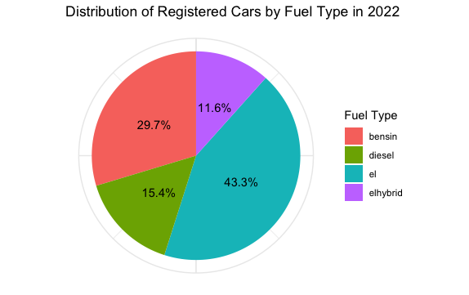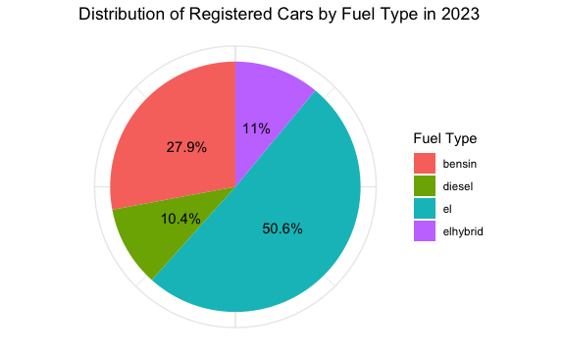

Figure 1 - To the left, Distribution of registered cars in 2023. To the right, Distribution of registered cars in 2023

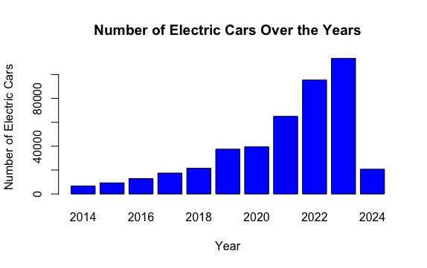

Figure 2 - New registrations for electric and hybrid cars

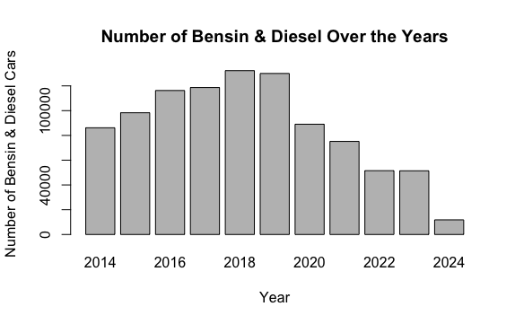

Figure 3 - Decreasing number of new registrations of gas and diesel cars

## Economic Incentives for Electric Vehicles

In addition to the environmental benefits, the economic advantage of electric cars contributes significantly to their growing popularity. Let’s break down the cost considerations and potential savings associated with owning an electric car compare to traditional gasoline and diesel cars.

When evaluating the cost of ownership, it's essential to consider not only the initial purchase price but also the ongoing expenses related to fuel or charging, and maintenance.

On average, electric vehicles tend to have a slightly higher upfront cost compared to their gasoline or diesel counterparts. However, this difference is gradually narrowing as technology advances and production scales increase. For example, based on recent data from Blocket, the average price for a used electric car from 2019-2024 is 332 000 SEK, while used diesel and gasoline cars average are 318 000 SEK and 247 000 SEK, respectively.

The cost of fuel or charging is a significant factor in the total cost of ownership. Diesel and gasoline cars rely on fossil fuels, subject to unstable market prices. According to recent data, the todays cost of diesel is 18.44 SEK per liter, while gasoline costs 19.49 SEK per liter. Based on a Volvo V40, diesel cars consume about 0.42 liters per kilometer, and gasoline cars consume about 0.41 liters per kilometer.

Electric cars, on the other hand, can be charged at home or at public charging stations. The average charging cost for electric cars is around 5 SEK/kWh using a public charging station. Considering a new Volvo EC40 that has an energy consumption of 16.8 kWh per 100 kilometers, the charging cost is approximately 8.40 SEK per 100 kilometers.

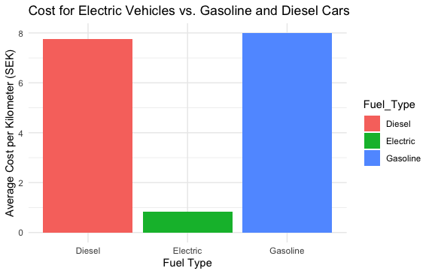

Figure 4 - Average cost of driving with diesel, electric and gasoline

Despite the slightly higher initial purchase price, electric cars offer significant long-term savings potential due to lower fuel/charging costs and reduced maintenance expenses.

Electric cars can save owners a substantial amount on fuel or charging costs compared to gasoline or diesel cars, especially over extended periods. The lower cost of electricity and higher energy efficiency of electric drivetrains result in significant savings on a per-kilometer basis.

Electric cars also have fewer moving parts and require less maintenance than internal combustion engine vehicles. With fewer components prone to wear and tear, owners can expect lower maintenance costs over the vehicle's lifespan.

Overall, while electric vehicles may require a slightly higher initial investment, the potential savings in fuel/charging costs and maintenance expenses make them a financially attractive option in the long run. Additionally, ongoing advancements in technology and infrastructure are expected to further enhance the cost-effectiveness of electric cars in the future.

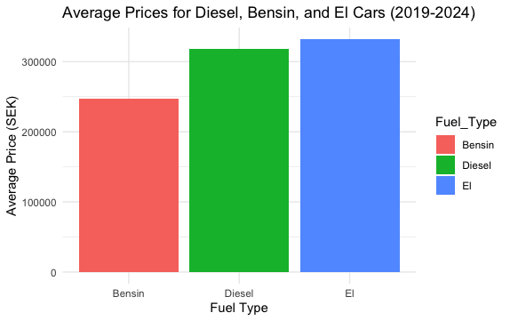

Figure 5 - The average price for a used car

## Regression modeling for Price Prediction

Regression modeling is an exceptional tool for predicting the price of an electric car based on various factors such as model year, mileage and brand.

In this project I’ve used data from car advertisements on Blocket.se and the predicted prices for a 2-year-old electric car from Volvo in 2025 is approximately 545 000 SEK and 566 000 SEK in 2026. These predictions are based on the regression model trained on historical data, and with factors like a maximum of 8000 miles and within the region of Stockholm.

Regression modeling enables us to forecast the price trends of electric vehicles, providing valuable insights for consumers, manufacturers, and policymakers in planning for the future of sustainable transportation.

By leveraging regression modeling, stakeholders can make informed decisions regarding pricing strategies, investment in electric vehicle technology, and the development of supportive infrastructure to promote the widespread adoption of electric vehicles.

## Environmental Impact of Electric Vehicles

Recent studies have shown that a Tesla 3 produces almost 19 tons of carbon dioxide when manufactured, where the battery alone stands for almost half of the emissions. This number can be compared to a Volkswagen Passat that produce almost 10 tons. With these numbers anyone can start to question how great an electric car actually is for the environment.

Luckily for us, the answer to this was also stated in the same study. During the whole life cycle of a Tesla 3 it emits 29 tons of carbon dioxide, which include the almost 2000 kg from just the scrapping. The same cycle of a Volkswagen Passat emits 43 tons, and it’s stated that an electric car is much better choice for the environment.

In addition to reducing emissions, electric cars are inherently more energy-efficient than conventional cars, by converting energy from the battery to kinetic energy - this results in lower energy consumption per mile traveled. Electric cars can also be charged using renewable energy sources as solar and wind power, further reducing their carbon footprint and promoting the adoption of clean energy technologies.

# Method

We started this task with a group assignment where we collected the data manually from car ads on Blocket.se, and we finished with 700 unique observations and 15 variables. I preparade the data by converting it into a data frame, and each variable into factors and numeric data. This was the only solution I found to all the error codes I got later on in the code, error codes that didn’t really had anything to do with the data type. Since I’m familiar with the data I knew that we had some outliers and that the model wouldn’t be perfect, and my R-squared score came up to 85% along with a F-statistic of 38.42 with a very low P-value.

I checked the coefficients and added a lot of code to fix new error codes I got when I tried using the test set, and the RMSE later returned 78 390. I continued with adding a squared term of the model year to find any potential nonlinear relationships with the car prices and the model slightly improved. The new RMSE returned 46 086 and I’m pretty happy with the results.

I looked for outliers using Cook’s distance and checked for anomalies but since the values are genuine data points I choose not to make any changes. The outliers could also be the reason why my Shapiro-Wilk test showed that my data wasn’t normally distributed.

I then began to predict the price for a 2-year-old electric car from Volvo, that had driven less than 8000 mils and was sold within the region of Stockholm. The price for 2025 came out to 545 189 SEK and 566 333 SEK for 2026. This seems a bit high since we only picked out ads for our data that had a price under 500 000 SEK. It might also be a user error since the data didn’t include any electric cars from Volvo in Stockholm, and we might would’ve gotten a better result with a bigger data set.

I then created an API to load the data from SCB, and converting it into a data frame. I converted the months into years and preformed a regression analysis on the data. The result showed my R-squared score at only 51% with a F-statistic of 218 with a very low P-value. The calculation of VIF showed that the model does not suffer from multicollinearity issues, however, I found out that the SCB data also wasn’t normally distributed – and for this I again blame the outliers.

I ended my code by plotting the data for charts I could use for this report.

Figure 6 - Cook's distance plot of Blocket data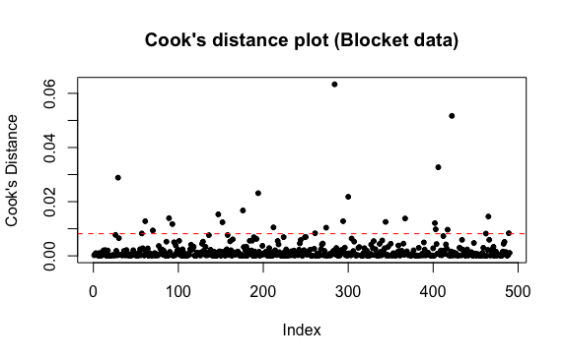

# Results

Well, there is room for improvements for sure. Neither of the models perform any good in the end, and there are a lot of thing that could’ve been made to get a better result. For one, I could have removed the outliers completely, and that would probably improve my models and the outcome.

I chose not the remove the outliers because I believed they provided valuable insights, like a Tesla Y that has over 500 horsepower or that the government offered subsidies for buying an electric car – only to later announce its removal, making a lot of people run to car dealerships.

Overall, I think the models did an okay job, considering the above. The predictions of the prices might or might not be correct. For what I’ve seen the prices of cars does actually rises along with new and improve technology, and my data does show that the prices is higher today than what it was 5 years ago.

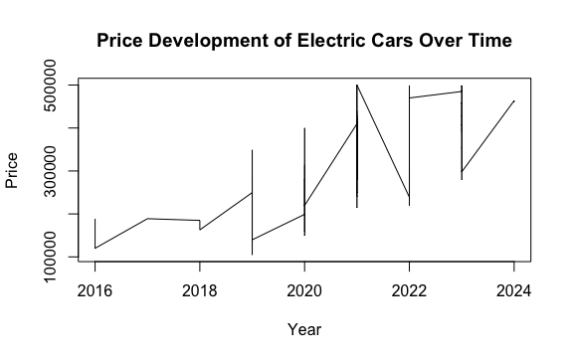Figure 7 - Price development for electric cars

# Conclusions

The data shows that the electric car is here to stay. Even though the largest cities in Sweden is more adapted for electric vehicles, smaller regions like Gotland still register more electric cars than Skåne – in proportion of course.

Every year the electric car grows a bigger slice on the pie chart and the cost savings might have role to play in that. You don’t have to be a math expert to calculate that electric cost less than both diesel and gasoline, even I managed to do that.

With tools like regression modeling we can predict future prices on cars. Even if the example under “Method” is great, I would probably not use the same data set where only a small portion of the cars were electric. And probably had more observations than what we collected. But only looking at the actual functionality, it’s a fantastic tool!

And finally, how does addressing these objectives contributes to a deeper understanding of the evolving automotive landscape and its broader implications for sustainability and economic development? I don’t know about you, but I’ve learned a lot from my report.

Figure 8 - Proportions of electric cars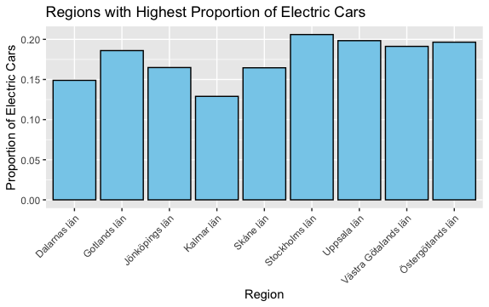

# Answers to Questions

1. Quantile – Quantile (QQ) är en metod som används för att jämföra två sannolikhetsfördelningar. Man plottar de ordnade värdena från den observerade datan mot de förväntade värdena från till exempel en normalfördelning. Med hjälp av metoden kan man alltså se om värdarna från den observerade datan också är normalfördelad.

2. I maskininlärning fokuserar man på att göra prediktioner utan att nödvändigtvis förstå sambanden mellan variablerna i detalj – det gör modellerna åt en, medans i statistisk regressionsanalys är också syftet att förstå sambandet mellan variablerna och göra statistiska inferenser om dessa samband, till exempel som hur mycket en variabel på verkar en annan och vilka faktorer som är viktiga.

3. Konfidensintervallet ger ett genomsnittligt mått medan prediktionsintervall ger varje enskild individ en uppskattning om vart de bör ligga, och tar också hänsyn till slumpmässiga variationen.

4. 𝑌= 𝛽0 + 𝛽1𝑥1 + 𝛽1𝑥2+...+𝛽𝑝𝑥𝑝 +𝜀.

𝛽0 är interceptet, det förväntade värdet på Y när x=0.

𝛽1𝑥1 är regressionskoefficienterna, förändringen i Y när x ökar och visar alltså lutningen

𝜀 är epsilon, felet i modellen som inte kan förklaras av de oberoende variablerna.

5. Tränings- och testdata behövs för att kunna utvärdera en modell, men valideringsdata behövs inte när man använder ett mått som BIC, som är baserad på statistiska mått som ger en hög tillförlitlighet. Fördelen med detta är man till exempel kan använda en mindre mängd data.

6. Metoden används för att välja den bästa möjliga uppsättningen av variabler för en regressionsmodell. Algoritmen används för att systematiskt identifiera den bästa modellen med den optimala uppsättningen av prediktorer för att förutsäga responsvariabeln.

7. Istället för att försöka få en modell att ge rätt svar i alla situationer – vilket är omöjligt - så borde vi fokusera på hur vi kan applicera modeller på ett användbart sätt i vår vardag.

# Self-Evaluation

I’ve had a lot of problems with writing the code in R, and I think I have almost 20 drafts saved on my computer. The variables from the Blocket data had all the correct data type but when I tried to use the test set for prediction it was suddenly just empty. I checked the variables/columns in the set and they were all there but for some unknown reason I couldn’t use it. This problem was continued for over a week, and after I added “solutions” and restarted R/my laptop/creating new files many times it somehow fixed itself. R also claimed that my horse power column had NA in it, but as you can see in my code I fixed that with means, but it didn’t work for a very long time, and that too somehow fixed itself after many reruns.

I hope I’ve showed enough skills and knowledge to pass this course.

Thank you for reading, and I hope you get some use of your new knowledge of electric cars.

# Data collection

I worked in a group with Arina, Filip, Muhammad, Shangchanhui (Amy) and Shriya, and after we were done we got two new members of Turzo and Wissam.

Filip created an excel file in Teams that we all could write in. We agreed on some requirements for the ads and made 100 observations each. We had great conversation in the chat and everyone got their work done before deadline.

For me it’s important to do what we have agreed on and on time, for respect to everyone in the group and to not delay anyone from getting started with the coding, and I feel like I did just that on this task. I’m pleased of the teamwork and what we achieved.

# Source list

Trafikverket (2024). Elfordon – så funkar det. <https://www.trafikverket.se/om-oss/skydda-klimat-miljo-och-halsa-i-vart-arbete/elfordon--sa-funkar-det/> (Retrieved 2024-04-28

Ellevio (2023). Elbilen – Nutiden framtidsmaskin och en överlevare i nästan 200 år. <https://www.ellevio.se/privat/energismart/historia/elbilen--nutidens-framtidsmaskin-och-en-overlevare-i-nastan-200-ar/>. (Retrieved 2024-04-28)

Allt om elbil (2023). Så mycket mindre släpper elbilen ut än dieselbilen. <https://alltomelbil.se/sa-mycket-mindre-slapper-elbilen-ut-an-dieselbilen/>. (Retrieved 2024-04-28)

Naturskyddsföreningen (2021). Vanliga frågor om bilar, klimat och miljö. <https://www.naturskyddsforeningen.se/artiklar/vanliga-fragor-om-bilar-klimat-och-miljo/> (Retrieved 2024-04-28)

Circle K (2024). Drivmedelspriser – bensin & dieselpriser. <https://www.circlek.se/drivmedel/drivmedelspriser>. (Retrieved 2024-04-29)

Tibber (2023). Hur mycket kostar det att ladda en elbil? <https://tibber.com/se/magazine/power-hacks/kostnad-ladda-elbil>. (Retrieved 2024-04-29